

Software Requirements Specifications
New Okhla Industrial Development Authority

Version 1.0

North Shore Technologies Pvt. Ltd.
_________________________________________________________________

Logix Techno Park ♦ Sector 127 ♦ Noida – 201301 ♦ India
Phone : (120) – 404 3401

Revision History

Ver. | Date | Notes | Author | Reviewed By | Approved By
0.1.0 | 28/12/2015 | SRS | Arun Sharma
0.2.0 | 22/02/2016 | SRS | Ankit Jain
0.3.0 | 23/02/2016 | Restructured, additions | Ankit Jain
0.4.0 | 27/02/2016 |  | Ankit Jain
0.5.0 | 23/06/2016 | SRS | Arun Sharma

Contents
Revision History 2
1. Introduction 5
1.1. Purpose of SRS 5
1.2. Scope of the Project 5
1.2.1. Developing a Web Enabled Integrated Property Information System 6
1.2.2. Digitization 6
1.2.3. Data correction 8
1.3. Users & Roles 9
1.4. Reference Documents 10
2. Functional Requirement 11
2.1. Application Workflow 11
2.2. Use Cases 13
2.2.1. Use Case - User Login 14
2.2.2. Use Case - Forgot Password 15
2.2.3. Use Case - User Logout 16
2.2.4. Use Case - Register New User 16
2.2.5. Use Case – View Dashboard and Reports 17
2.2.6. Use Case – Dashboard: View Allocation by Property Type 18
2.2.7. Use Case –View Property Details 20
2.2.8. Use Case – Payment Schedule details 21
2.2.9. Use Case – Jal Payment History 23
2.2.10. Use Case – Add Remark 23
2.2.11. Use Case – Dashboard: View Defaulted Payment 24
2.2.12. Use Case – Dashboard: View Customer Complaints / Service Requests 25
2.2.13. Use Case – Dashboard: View Revenue by year 27
2.2.14. Use Case – Property: View All Property List 28
2.2.15. Use Case – Finance: View all Payments 29
2.2.16. Use Case – Litigation: View Legal Cases 30
2.2.17. Use Case – Advance Search 32
2.2.18. Use Case – Search by Location 32
2.2.19. Use Case - Administration 33
2.2.20. Use Case – My property 34
2.2.21. Use Case – Transfer History 34
2.2.22. Use Case – Allotment 35
2.2.23. Use Case – Lease Deed 35
2.2.24. Use Case – Submit Feedback 36
2.2.25. Use Case – Payment Schedule 36
2.2.26. Use Case – Make Payment 37
2.2.27. Use Case – Payment History 38
2.2.28. Use Case – Notices 38
2.2.29. Use Case – JAL 39
2.2.30. Use Case – Service Request 39
2.2.31. Use Case – New Service request/Complaint 40
2.2.32. Use Case – Track 41
2.2.33. Email/SMS Notification 41
2.3. Reference Table for Functionality 42
3. Non Functional Requirement 43
3.1. Usability 43
3.2. Reliability 43
3.3. Performance 43
3.4. Supportability 43
3.5. Design Constraints 44
4. Assumptions 44
Glossary 45

Introduction
NOIDA Constituted under the U.P. Industrial Area Development Act, 1976, has now emerged as a planned, integrated, modern Industrial City, well connect to Delhi through a network of roads, national highways and the ultra - modern DND flyover, offering inter - road linkages to all parts of the country.NOIDA is one of the largest planned industrial townships of Asia, because of this fact NOIDA Authority deals with huge amount of data and large number of transactions related to their properties and customers. Therefore, an optimized system is required that would integrate and depict the consolidated view of all property related information.

The approach is to bring an integrated property information system for higher management/officers to monitor all-around activities within the Authority in order to strengthen the decision making capabilities. In addition to a better customer service, this system will ensure that the customer will get the complete information of his/her property. Using this system, the customer will also be able to make online payments and submit feedbacks/complaints.

1.1. Purpose of SRS

The purpose of this Software Requirements Specifications (SRS) document is to provide the detailed description of the Property Information System (hereafter designated as “PIS”).This document will describe how different users interact with the system. Detailed use cases are used to portray the functionalities of the system with respect to both the Admin and the Customer.

Intended Audiences for the SRS
- Noida Nodal Officers.
- Designers and Developers of the system.

1.2. Scope of the Project

The overall purpose of this project is to build up an integrated Property Information system. This system would primarily facilitate access on web browser. This system will automate various processes across and allow adoption of a comprehensive approach towards gaining the efficiency. This system would enable the working staffs, officer etc. to access integrated data from different business processes, thus, enabling them to promote information sharing for critical operational as well as strategic decision-making.

The scope of this project is to develop the Property Information System which will help the Noida officials and Customers to view property related information.

1.2.1. Developing a Web Enabled Integrated Property Information System
The main features of the system would be:

- Show categorisation of different property types.
- Reflect the various property details (Built up area, Plots etc.), lease deeds executed, mortgaged properties, transferred properties, completion certificate of the properties and account related details and payment history.
- Show the property owner name, property status (possession handed over, rented, allotted, functional etc.), area and location of property.
- Show the detailed payment history, paid/due payments, future payment due dates and amount.
- Send email notifications & reminders to customers about the due payments, if not paid timely. The information system will also send SMS alerts twice in a month (One month and 15 days before any payment due respectively).
- Show JAL payment receipts and dues, complaints & enquiry status from the Customer charter and any legal cases associated with the property.
- Contain a payment gateway for the customer for online payment of various instalments & fees related to property.
- Contain a dashboard used to generate reports on various parameters. This will ensures compliance and enhances the decision making between the Noida Authority Officials. Customers will also be able to generate reports regarding their payments (paid/dues).
- Enable the Noida Authority Officials to search any property using filters (property id#, owner name, address etc.) as per the requirements.
- Enable the Customer to search for the details of their property, payment etc. The system will also allow the Customer to register their query/complaints to their related property and able to track their complaints and query.

1.2.2. Digitization

Digitization of documents would involve scanning hard copy documents for all properties. These scanned documents would be retrievable from Property Information System. PIS will display the scanned digitized documents such as:

- Noting Sheet
- Allotment Letter
- Possession Letter
- Lease Deed
- Mortgage Letter
- Transfer Memorandum
- Transfer Deed
- Mutation Letter
- Completion Certificate
- NDC
- Time Extension Letter
- Form 9
- Application Form
- CIC Letter

Below diagram illustrates the complete Digitization process flow:
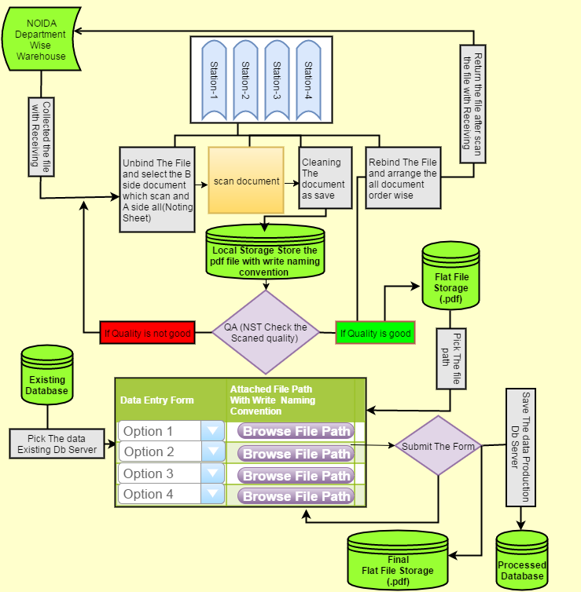

Figure 1: Digitization process

- Scanning of Documents: Documents will be scanned using advance scanning machines. Quality check and assurance will be done for ensuring the quality of the scanned images.

- Indexing of Documents: After successful scanning of documents, these scanned documents will be linked to the respective property id. By this way, an index would be created which would be used to fetch all related scanned documents for the respective property id.

- Storage: All scanned images will be stored in the database according to the property id. This will ensure the digitization of the physical documents.

- Retrieval of documents: All scanned documents will be available for retrieval using the Property Information System.

1.2.3. Data correction

Correction of data ensures integrity of information and thus, integrity of the system. Process of data correction typically involve go through of the database for all properties. Data would be validated and verified between the physical files and the database on the basis of below cases:

Case 1: If Data related to a property is completely missing.

- In this case, no record exists for the property in database.
- Complete data would be entered into database from the physical files.

Case 2: If some attributes of the data related to a property is missing.

- In this case, information is missing for the property in database.
- Missing information would be identified and updated into database.

Case 3: In case of deviation of information between physical file and database.

- Deviated information would be first verified by coordinating with concern department.
- Correct data would be updated after fulfilling relevant procedures set up by the Authority.

We have identified the set of fields of important attributes related to properties from the database system. These data fields would be validated against the above three cases and then, corrected/missing data fields would be updated into database.

Below is the list of the fields with their use:

SNO | COLUMN_NAME | DESCRIPTION
1 | PLDRACTUAL_LAND_AREA | Actual Land Area
2 | PRDBIS_NAZUL_PROPERTY | Government Property(Nazool) or Not
3 | PRDRLANDRATE | Rate of land per Area part
4 | PLDVSCHEME_NAME | Name of the scheme
5 | PRDDALLOTMENT_MODE_DATE | Date of Allotment
6 | PRDDCHANGED_DATE | Date when changed
7 | PRDRCONS_CHANGE_CHARGE | Charge for the Change
8 | PRDVCHANGED_DIRECTOR_NAME | Changed Director Name
9 | PRDVNEW_FIRM_STATUS | Status FLAG for the Firm
10 | PRDVDIRECTORS_NAME | Name of the Director
11 | PRDVFIRM_NAME | Name of the Firm
12 | PRDVFIRM_TYPE | Type of Firm
13 | LEASERENT_UPTO | Lease Rent Date (Valid up to)
14 | NDC_DATE | Date when Lease taken
15 | ONE_TIME_LEASE | one time lease(Yes or No)
16 | PRDDAPPLICATION_DATE | Application date for property to be rented
17 | PRDVTENANT_NAME | Name of the tenant(person to whom property rented out)
18 | PRDVTENANT_PROJECT | Project for which property rented out
19 | PRDDACTUAL_AFFIDAVT_DATE | Affidavit Date
20 | PRDDAPPLICATION_DATE | Date of Application
21 | PRDDAPPROVAL_DATE | Date of Approval for Mortgage
22 | PRDVMORTGAGED_NAME | Bank Name
23 | PRDDATTORNEY_DATE | Date of Attorney
24 | PRDVADDRESS | Address of the Applicant
25 | PRDVHOLDER_FATHER_NAME | Name of Attorney holder's Father
26 | PRDDALLOTMENT_DATE | Property Allotment Date
27 | PRDDPOSSESSION_DATE | When Possession Date
28 | PRDRAMOUNT | Amount for the Possession
29 | PRDDTRANSFERDEED_DATE | Date of Deed transfer from one person to another
30 | PRDRAMOUNT | Total amount of land (rate of land * Area of land)
31 | PRDVAPPLICANT_FATHER_NAME | Applicant's Fathers Name
32 | PRDVPERMANENT_ADDRESS | Permanent address of the applicant
33 | PRDVREGIST_APPLICANT_NAME | Applicant Name/Property holder Name
34 | PRDKHATA_NO | Khasra No. / Khata No. Only for villagers. 5 % of population
35 | PRDVAPPLICANT_FATHER_NAME | Applicant father Name
36 | PRDVREGIST_APPLICANT_ADDRESS | Applicant Address
37 | PRDVREGIST_APPLICANT_NAME | Applicant name
38 | PRDDINST_START_DATE | Instalment start date
39 | PRDIFREQUENCY_OF_INST | Half yearly, Yearly, Monthly etc.
40 | PRDIPRINCIPLE_AMT | Principle Amount
41 | PRDITOTAL_NO_OF_INST | Total Number of Instalments
42 | PRDDRENTING_DATE | Date when Property Rented
43 | SECTOR | Sector
44 | BLOCK | Block
45 | PROPERTY_NO | Property Number

Table 1: Data Correction Fields

1.3. Users & Roles

Following users are the intended audience for this system:

Administrator users includes audience like ACEO/DCEO/FC.
Department Head are the user who will be viewing there personalize dashboards.
Customer would be registering them self and would be activated by the back office role only.

These users would be assigned a role, according to which they will interact with the System.

- Back-office Role : This role will be created from the back end. The back office user will manage customers and internal users. These users would be able to see the consolidated view of the Information related to the properties and payments.

Users for under this role:
- Department (Department Head)
- Administration Department (ACEO/DCEO/CEO/Finance Controller (FC)).
- Customer Role: These users would be able to see the information related to their own property and also respective payments. These users would also perform transactions towards their payments.

Users for under this role:
- Customer/Citizen

- Super Administrator Role: These users would be able to support the system technically and would have the root level rights of the system.

Users for under this role:
- System Administrator

1.4. Reference Documents
Sl. No | Document Title | Document Link

Table 2: Reference Documents

Functional Requirement

2.1. Application Workflow

- Application workflow for Customer:

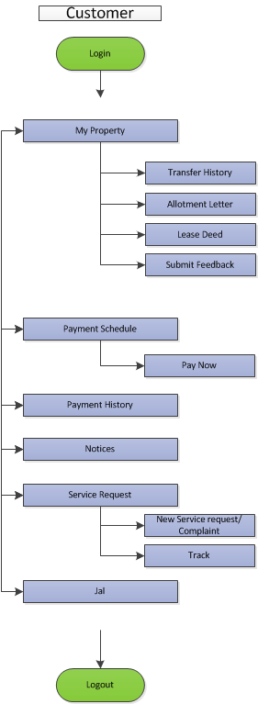

Figure 2: Application workflow: Customer

- Application workflow for Admin:

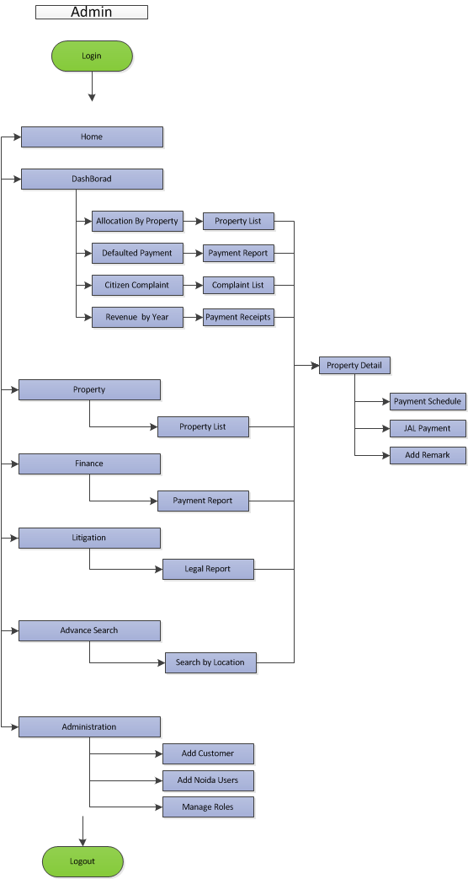

Figure 3: Application workflow: Admin

User group:

User Group | Roles
Department head | Admin
Higher Authorities(A CEO/D CEO/CEO/FC) | Admin
Customer | Customer
Table 3: User group

2.2. Use Cases

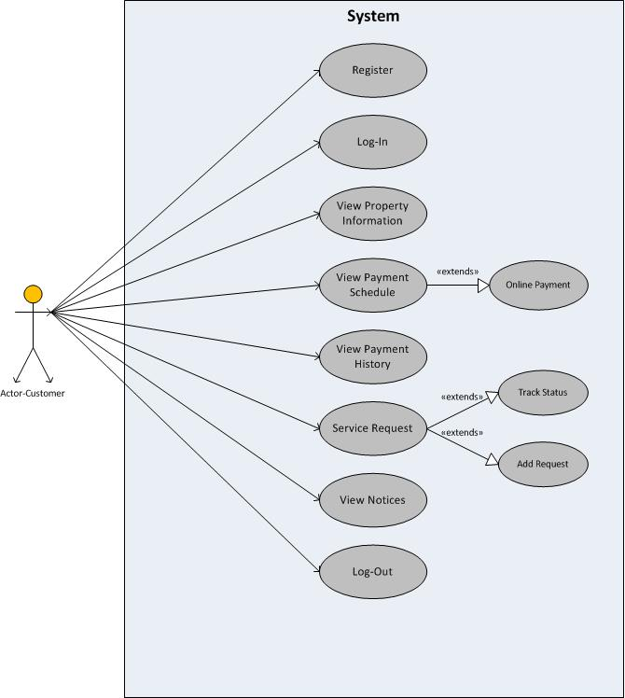
Figure 4: Use Case Customer

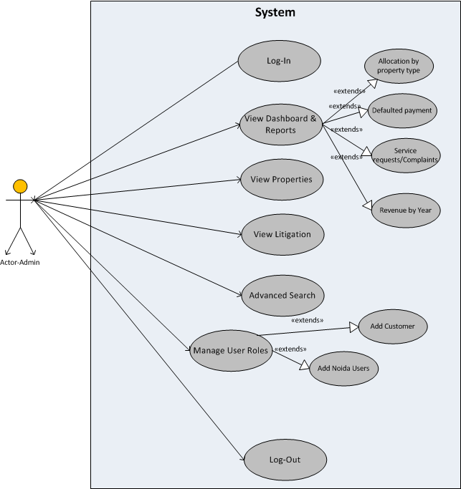
Figure 5: Use Case Diagram Admin

2.2.1. Use Case - User Login

Use Case Name | User Login
Description | Represents how an actor logs into the system
Actors | Admin, Customer
Rules | N/A
Used use case | None
Pre-Conditions | - A valid Internet connection.  - Login id & password.
Basic Flow | Navigation: PIS -> Login  - Actor enters his username (email) and password on the screen to login.  - The system validates username and password.  - After successful validation, actor logs into the system.
Post-Conditions | - After login, home screen of PIS will be displayed to actor.
Alternate Flow | 1. Invalid Name / Password  If actor enters an Invalid username and/or password then, system redirects the Actor to the login screen with an error message “Invalid username or password”.

2.2.2. Use Case - Forgot Password

Use Case Name | Forgot Password
Description | This use case represents, how an actor can reset password.
Actors | Admin, customer
Rules | N/A
Used use case | None
Pre-Conditions | - A working Internet connection  - Login Id
Basic Flow | Navigation: Login Screen -> Forgot Password  - Actor clicks on “Forgot Password” option.  - “Forgot Your Password?” pop up box is displayed.  - Actor enters the email address and clicks on the Submit button.  - A password reset link is sent on the email address provided by the Actor.  - A popup message “An email with instructions has been sent to you on your registered email address” would be displayed.  Extension:  - Actor clicks on password reset link provided in the email.  - Actor is directed on a web page for providing new password.  - Actor provides a new password and clicks on submit button.  - Message “password has been changed successfully” is displayed on the web page.
Post-Conditions | Password is changed and message “password has been changed successfully” is displayed on the web page.
Alternate Flow | - Email Not Registered in system  If, email address entered by the actor does not exist in the system a message “Email not found” is displayed.

2.2.3. Use Case - User Logout

Use Case Name | Logout
Description | This use case enables the actor to logout from the system.
Actors | Admin, Customer
Rules | N/A
Used use case | None
Pre-Conditions | Actor should be logged in to the system.
Basic Flow | Navigation: Sign Out option is available on every screen in PIS.  - Actor clicks on sign out option.  - Actor logs out of the system and directed to the login screen.
Post-Conditions | Actor is successfully logged out from the system.

Use Case – Change Password

Use Case Name | Change Password
Description | This is the use case for changing the password for users.
Actors | Admin, Department Head, Back Office Operator
Rules | - New password and old password should not match.  - Password reset policy for mandatory change of password in every 90 days.
Used use case | None
Pre-Conditions | - User should be logged in to system.
Basic Flow | - Actor clicks on “Change Password “option on the home screen.  - Screen would display a form containing below fields:  - Old Password: Textbox (mandatory)  - New Password: Textbox (mandatory)  - Confirm New Password: Textbox (mandatory)  - Actor would provide new password two times to confirm and click on ‘submit’ button to save new password or alternatively click on ‘cancel’ button to go back to home screen.  - System would verify the old password and reset it to new one. User will get the alert message “Password changed successfully”.  Note: All the mandatory fields would be denoted by an *(asterisk).
Post-Conditions | The system will change the password for the actor.
Field Level Validations | - Old Password: Alphanumeric with special characters allowed maximum 255 characters. Validate from database. It must contain:  - An uppercase alphabet.  - A lower case alphabet.  - A number.  - A special character.  - Minimum 8 characters long.  - New Password: Alphanumeric with special characters allowed maximum 255 characters. Validate from database. It must contain:  - An uppercase alphabet.  - A lower case alphabet.  - A number.  - A special character.  - Minimum 8 characters long.  - Confirm New Password: Alphanumeric with special characters allowed maximum 255 characters. Validate from database. It must contain:  - An uppercase alphabet.  - A lower case alphabet.  - A number.  - A special character.  - Minimum 8 characters long.  - Should match with the new password field.

Use Case - Register New User

Use Case Name | Register New User
Description | This is the use case for registration of a New User
Actors | Admin, Customer
Rules | - In case of transfer request of the property transferor registration account will be deactivated and transferee has to register as a new user into the system.
Used use case | None
Pre-Conditions | - A valid Internet connections.  - Once scanned Id proof, which can be Voter id, PAN card, AADHAR UID  - One scanned Property Document, which can be Allotment letter or Lease Deed.
Basic Flow | The action begins at the login page once the actor clicks on the ‘Register here” button.  - Actor fills the form asking for the information (PID) of the user.  - Once the PID found an OTP will be sent on actor’s mobile and Email.  - Actor confirms the OTP completes step 1 of registration.  - Step 2, Actor also upload one scanned copy of valid id proof and one scanned copy of one of the two property documents.  - Actor submits the form  - After verification and user id and password will be sent to the actor on mail and mobile number.
Post-Conditions | The system will register new user to the system.
Alternate Flows | 1. Valid email address  Actor should enter valid email address. In the case of invalid email address, message will be displayed as “Email not found”.  2. Invalid Property Id  Actor should entered registered property Id in the system. In the case of Property Id doesn’t exist in the system, message will be displayed as “Property id not found”.  3. Cancel Button  Actor clicks on the “Cancel Button” and is redirected to the Login page.

2.2.5. Use Case – View Dashboard and Reports

Use Case Name | View Dashboard and Reports
Description | This use case allows the admin to have a consolidated view of statistics in the Dashboard.
Actors | Admin
Used Use Case | 2.2.6 Allocation by Property type,  2.2.11 Defaulted Payments,  2.2.12 Customer complaints/service request,  2.2.13 Revenue by year
Pre-Conditions | Actor should logged in as admin into the system.
Basic Flow | Navigation : Home Screen -> Dashboard  1. The use case starts when actor clicks on Dashboard option.  2. Actor is directed to a screen where he can see the consolidated view of the following:  - Allocated properties of different property types (pie chart)  - Quarterly Defaulted payments which is further divided based on property types (bar graphs)  - customer complaints and service requests based on the status of complaints/request (pie chart)  - Year wise revenue generated (bar graph)  3. If Actor wants to see list of allocated properties then, use  2.2.6 Allocation by Property type  4. If actor wants to see list of defaulted payments then, use  2.2.11 Defaulted Payment  5. If actor wants to see list of complaints/service request then, use  2.2.12 Customer Complaints/Service Requests  6. If actor wants to see list of payment receipt for revenue, then use  2.2.13 Revenue by Year
Post-Conditions | System displays various graphs and charts
Alternate Flows | If Actor wants to see the dashboard for a particular sector then, he can select the desired sector from the dropdown option available on dashboard

2.2.6. Use Case – Dashboard: View Allocation by Property Type

Use Case Name | View Allocation by Property Type
Description | This use case is to get the list of the allocated properties according to the property type
Actors | Admin
Used use case | 2.2.7 Property details
Pre-Conditions | Actor should logged in to the system as admin.
Basic Flow | Navigation: Dashboard->Allocation by property type  1. This use case starts when actor clicks on a segment of the pie chart for allocation by property.  2. System displays a list of properties for respective property type segment.  3. If actor wants to see the property details for a particular property then, use  2.2.7 Property Details  Extension :  1) Actor searches for the desired properties using the following Options:  - Property type  - Sector  - Block  - Property Number  2) Actor aggregates the result by drag and drop one or more from the following column headers to the group by area:  - Registration Id  - Property No  - Property type  - Sector  - Block  - Plot no  - Area (sq.mt.)  - Allottee Name  3) Actor filters the result set using one or more of the following column headers:  - Registration Id  - Property No  - Property type  - Sector  - Block  - Plot no  - Area (sq.mt.)  - Allottee Name
Post-Conditions | System displays list of properties, based on the selection of respective property type segment of the pie chart.

2.2.7. Use Case –View Property Details

Use Case Name | View Property Details
Description | This use case is for displaying the details of a property.
Actors | Admin
Rules | All the property details are tightly integrated with each other.
Used use case | 2.2.8 Payment Schedule,  2.2.9 JAL Payment,  2.2.10 Add Remark
Pre-Conditions | Actor should logged in to the system as admin.
Basic Flow | Navigation:  Dashboard -> Allocation by property type -> Property Details  Dashboard -> Defaulted Payments -> Property Details  Dashboard -> Complaints List/Service Requests -> Property Details  Dashboard -> Revenue by Year -> Property Details  Home -> Property -> Property Details  Home -> Finance -> Property Details  Home -> Litigation -> Property Details  1. This use case starts when actor clicks on a registration number/property number.  2. System displays property details based on the selection.  - Property Details  - Payment History  - Complaints/Service Requests  3. If actor wants to see the payment schedule for the property then, use  2.2.8 Payment schedule  4. If actor wants to see the JAL payment history for the property then, use  2.2.9 JAL Payment History  5. If actor wants to add remarks then , use  2.2.10 Add Remark.
Post-Conditions | System displays the property details.

2.2.8. Use Case – Payment Schedule details

Use Case Name | Payment Schedule Details
Description | This use case is for displaying the payment schedule of a property
Actors | Admin
Rules | 1) Property type Industrial  Payment Schedule is Equally parted  The calculation of the payment schedule for Industries would be done using Equated Monthly Instalments. The formula for the same is as follows:  n = Number of instalment  r = Rate of interest,  Rate of Interest, r = [N.I./(12/f)]  f = frequency  N.I.= Normal Interest  Calculation of rate of interest as per frequency:  - In case of Monthly  Frequency, f=12  Rate of Interest, r = N.I./(12/12) [from the rate of interest formula above]  - In case of Quarterly  Frequency, f=4  Rate of Interest, r = N.I./(12/4) [from the rate of interest formula above]  - In case of Half Yearly  Frequency, f=2  Rate of Interest, r = N.I./(12/2) [from the rate of interest formula above]  - In case of Yearly  Frequency, f=1  Rate of Interest, r = N.I./(12/1) [from the rate of interest formula above]  The factor can be calculated as  Factor,  F=[POW((1+r/100),n)*r/100]/[POW((1+r/100),n)-1]  So, the instalment amount can be calculated as the product of Balance Amount and the Factor (calculated using the above formula), i.e.:  Instalment Amount = Balance Amount * Factor  Note:  - For the industrial properties, payment cycle starts on 30th June or 31st December.  - The first instalment will be applicable after 6 months from receiving allotment letter.  - The amount of the first instalment will be comparatively high from the amount of remaining instalments. After allotment, a customer will start the payment of instalment after minimum 6 months. In industries, a customer can pay only 2 times in a year and that too half-yearly i.e. on 30th June or 31st December. For example, if the customer receives the allotment letter on 21st February, the first instalment will start from 31st December, instead of 30th June because the customer didn’t completed 6 months (requirement after allotment) after allotment till 30th  2) Property Type Institutional, Commercial, Group Housing, Residential, Housing  The calculation of the payment schedule for Institutions would be done using Reducing Monthly Instalments. The formula for the same is as follows:  Total Premium Balance Amount = Total Cost of property – (allotment money + earnest money)  Principal Amount= Total Premium Balance Amount/No. of Instalments  The first instalment in reducing monthly instalment method can be calculated as:  First Instalment Interest Calculation = [Total Premium Balance Amount * (Rate of Interest/Frequency)]/100  Premium Balance Amount = Premium Balance Amount - First Instalment Principal Amount  From First Instalment Interest onwards,  Second Instalment Interest Calculation = [Balance Premium Amount *(Rate of interest/Frequency)]/100  Premium Balance Amount = Premium Balance Amount - Second Instalment Principal Amount  Similarly,  Nth Instalment Interest Calculation = [Balance Premium Amount *(Rate of Interest/Frequency)]/100  Premium Balance Amount = Premium Balance Amount - nth Instalment Principal Amount
Used use case | None
Pre-Conditions | Actor should logged in to the system as admin.
Basic Flow | Navigation:  Property details -> Payment Schedule  1. This use case starts when actor clicks on payment schedule  2. System displays payment schedule for the property.
Post-Conditions | System displays payment schedule for the property

2.2.9. Use Case – Jal Payment History

Use Case Name | Jal Payment History
Description | This use case is for displaying the JAL payment history for a property
Actors | Admin
Rules | N/A
Used use case | None
Pre-Conditions | Actor should logged in to the system as admin.
Basic Flow | Navigation:  Property details -> JAL payment history  1. This use case starts when actor clicks on JAL payment history.  2. System displays JAL payment history for the property.
Post-Conditions | System displays Jal payment history for the property

2.2.10. Use Case – Add Remark

Use Case Name | Add Remark
Description | This use case is for adding a remark for a property
Actors | Admin
Rules | N/A
Used use case | None
Pre-Conditions | Actor should logged in to the system as admin.
Basic Flow | Navigation:  Property details -> Add Remarks  1. This use case starts when actor clicks on Add Remark button.  2. System displays a popup box and requests actor to enter a comment.  3. Actor enters a comment.  4. Actor clicks on submit button to add a remark
Post-Conditions | Actor successfully add a remark.

2.2.11. Use Case – Dashboard: View Defaulted Payment

Use Case Name | View Defaulted Payment
Description | This use case is to get the list of defaulted payments according to the property type
Actors | Admin
Rules | Defaulted payment is calculated for each property  Using quarterly reconciliation for individual properties  Dues, after penal interest applicable gives the defaulted payment.
Used use case | 2.2.7 Property details
Pre-Conditions | Actor should logged in to the system as admin.
Basic Flow | Navigation: Dashboard->Defaulted Payment  1. This use case starts when actor clicks on a segment of the bar graph for quarterly defaulted payments.  2. System displays the bar graphs for different property types based on the selected quarter.  3. Actor selects the segment for a particular property type.  4. System displays list of defaulted payments based on selection of the property type.  5. If actor wants to see the property details for a particular property then, use  2.2.7 Property Details  Extension :  1) Actor searches for the desired payments based on following options:  - Property type  - Sector  - Block  - Payment Status  2) Actor aggregates the result by drag and drop one or more from the following column headers to the group by area:  - Registration Id  - Property type  - Sector  - Account  - Amount Due  - Amount Paid  - Allottee Name  3) Actor filters the result set using one or more of the following column headers:  - Registration Id  - Property type  - Sector  - Account  - Amount Due  - Amount Paid  - Allottee Name
Post-Conditions | System displays list of defaulted payments, based on the selection of respective property type segment of the bar graph.

2.2.12. Use Case – Dashboard: View Customer Complaints / Service Requests

Use Case Name | View Customer Complaints / Service Requests
Description | This use case is to display the list of Customer Complaints / Service Requests.
Actors | Admin
Used use case | 2.2.7 Property details
Pre-Conditions | Actor should logged in to the system as admin.
Basic Flow | Navigation: Dashboard->Customer Complaints / Service Requests  1. This use case starts when actor clicks on a status segment of the pie chart for Customer Complaints / Service Requests.  2. System displays list of complaints / service requests based on the selected status segment.  3. If actor wants to see the property details for a particular property then, use  2.2.7 Property Details  Extension :  1) Actor aggregates the result by drag and drop one or more from the following column headers to the group by area:  - Registration Id  - Complaint no.  - Subject  - Created Date  - Due Date  - Department  - Location  - Customer Name  - Mobile no.  - Status  2) Actor filters the result set using one or more of the following column headers:  - Registration Id  - Complaint no.  - Subject  - Created Date  - Due Date  - Department  - Location  - Customer Name  - Mobile no.  - Status
Post-Conditions | System displays list Complaints / Service Request based on selection.

2.2.13. Use Case – Dashboard: View Revenue by year

Use Case Name | View Defaulted Payment
Description | This use case is to get the list of payments receipt accountable for revenue, according to the property type.
Actors | Admin
Used use case | 2.2.7 Property details
Pre-Conditions | Actor should logged in to the system as admin.
Basic Flow | Navigation: Dashboard->Revenue by Year  1. This use case starts when actor clicks on a property type segment of the bar graph for yearly revenue details.  2. Based on the selection, system divides the bar graph in revenue from allotment and revenue from lease rent for the property type.  3. If actor further selects from lease rent or allotment, System displays list of payments receipt accountable for revenue, based on selection.  4. If actor wants to see the property details for a particular property then, use  2.2.7 Property Details  Extension :  1) Actor aggregates the result by drag and drop one or more from the following column headers to the group by area:  - Registration Id  - Property type  - Sector  - Deposit Date  - Depositor Name  - Department  - Head  - Amount  - Bank Id.  - Challan Id.  2) Actor filters the result set using one or more of the following column headers:  - Registration Id  - Property type  - Sector  - Deposit Date  - Depositor Name  - Department  - Head  - Amount  - Bank Id.  - Challan Id.
Post-Conditions | System displays list of defaulted payments, based on the selection of respective property type segment of the bar graph.

2.2.14. Use Case – Property: View All Property List

Use Case Name | View all Property List
Description | This use case is to get the list of the allocated properties according to the property type
Actors | Admin
Used use case | 2.2.7 Property details
Pre-Conditions | Actor should logged in to the system as admin.
Basic Flow | Navigation: Home -> Property  1. This use case starts when actor clicks on a Property option  2. System displays a list of all properties  3. If actor wants to see the property details for a particular property then, use  2.2.7 Property Details  Extension :  1) Actor searches for the desired properties using the following Options:  - Property type  - Sector  - Block  - Property Number  2) Actor aggregates the result by drag and drop one or more from the following column headers to the group by area:  - Registration Id  - Property No  - Property type  - Sector  - Block  - Plot no  - Area (sq.mt.)  - Allottee Name  3) Actor filters the result set using one or more of the following column headers:  - Registration Id  - Property No  - Property type  - Sector  - Block  - Plot no  - Area (sq.mt.)  - Allottee Name
Post-Conditions | System displays list of all properties

2.2.15. Use Case – Finance: View all Payments

Use Case Name | View all Payments
Description | This use case is to get the list of all payments
Actors | Admin
Rules | 1) Payment types includes both Property payments and JAL payments.  2) Payment status includes Dues and Defaulted  3) Calculation of Dues  Dues are calculated e.g., if an instalment is missed, it is marked as dues  Penal interest is applicable on dues  In case customer pay partial amount before due date of next instalment then, reconciliation takes place and penal interest is applicable  - Till date on the amount dues.  - Up to the due date for next instalment, on dues remaining (dues-partial payment)  In case customer pays amount on due date then reconciliation takes place on due date.  Penal Interest = P*(1+r/100) ^ n  4) Calculation of defaulted payments  Once penal interest applied on dues the amount is defaulted payment
Used use case | 2.2.7 Property details
Pre-Conditions | Actor should logged in to the system as admin.
Basic Flow | Navigation: Home -> Finance  1. This use case starts when actor clicks on finance option.  2. System displays list of all Payments.  3. If actor wants to see the property details for a particular property then, use  2.2.7 Property Details  Extension :  1) Actor searches for the desired payments based on following options:  - Property type  - Sector  - Block  - Payment Status  - Payment Type  2) Actor aggregates the result by drag and drop one or more from the following column headers to the group by area:  - Registration Id  - Property type  - Sector  - Account  - Amount Due  - Amount Paid  - Allottee Name  3) Actor filters the result set using one or more of the following column headers:  - Registration Id  - Property type  - Sector  - Account  - Amount Due  - Amount Paid  - Allottee Name
Post-Conditions | System displays list of all payments.

2.2.16. Use Case – Litigation: View Legal Cases

Use Case Name | View all Property List
Description | This use case is to get the list of all legal cases related to the properties
Actors | Admin
Used use case | 2.2.7 Property details
Pre-Conditions | Actor should logged in to the system as admin.
Basic Flow | Navigation: Home -> Litigation  1. This use case starts when actor clicks on a Ligation option  2. System displays a list of all legal cases.  3. If actor wants to see the property details for a particular property then, use  2.2.7 Property Details  Extension :  1) System displays legal cases , based on:  - Session Court  - Upper Court  2) Actor aggregates the result by drag and drop one or more from the following column headers to the group by area:  - Registration Id  - Case No  - Year  - Court  - Parties  - Advocate Name  - Address  - Status  3) Actor filters the result set using one or more of the following column headers:  - Registration Id  - Case No  - Year  - Court  - Parties  - Advocate Name  - Address  - Status
Post-Conditions | System displays list of all Legal cases

2.2.17. Use Case – Advance Search

Use Case Name | Advance Search
Description | This use case is for the advance search for Property, Payment, Legal and Defaulter
Actors | Admin
Used use case | 2.2.18 Search by Location
Pre-Conditions | Actor should be logged in as Admin into the system.
Basic Flow | Navigation: Home -> Advance Search  1. This use case starts when actor clicks on Advance Search option.  2. System displays a screen where actor defines a search criteria  - Actor selects from one search type at a time. These are  - Property,  - Payment,  - Legal,  - Defaulter.  - Actor defines search, using one or more of the following options:  - Property type,  - Block,  - Sector,  - Plot Number,  - Allottee Name,  - Property Number  3. Actor clicks on search button.  4. System displays the desired result.  5. If actor wants to search by location then, use  2.2.18. Search By Location
Post-Conditions | System displays the details as per the defined search.
Alternate Flows | 1. Cancel Button  Actor clicks on the “Cancel Button” and is redirected to the home screen of the system.

2.2.18. Use Case – Search by Location

Use Case Name | Search by location
Description | This use case is for search using location map
Actors | Admin
Used use case | 2.2.7 Property Details
Pre-Conditions | Actor should be logged in as Admin into the system.
Basic Flow | Navigation: Home -> Advance Search-> Search by Location  1. This use case starts when actor clicks on Search by Location option.  2. System displays a location layout map displaying property number.  3. Actor selects the property no from location map.  4. System displays basic info for the property  5. If actor wants to view complete property details then, use  2.2.7 Property Details
Post-Conditions | System displays basic property details.
Alternate Flows | 1. Cancel Button  Actor clicks on the “Cancel Button” and is redirected to the home screen of the system.

2.2.19. Use Case – Manage Administration
Use Case Name | Manage User Screen
Description | This is the use case for managing the back office users and customers.
Actors | Back Office
Rules | Back Office ID will be generated from back end.
Used use case | Add Users (Administrator, Department Head)
Pre-Conditions | Actor should be logged in as back office user into the system.
Basic Flow | Navigation: Home -> Administration  1. This use case starts when actor clicks on Administration.  2. System displays the grid along with below option:  - Add Noida Users  3. List (Manage Customer grid) will contain following columns with information:  - User Email Address  - Name  - Property ID  - Status  - Locked  - Actions: “Activate”, “Reject”  - Documents ID  - Letter Document  4. Actor would update the form for the creating the users as “Administrator” and “Department Head”.
Post-Conditions | User added successfully.
Alternate Flow | 1. Cancel Button  Actor submit on cancel button under manage user’s section the web page redirects to the home page.

2.2.20. Use Case – Add Users

Use Case Name | Add Internal Users
Description | In this use case the internal users will be created.
Actors | Back Office User
Rules | - New password and old password should not match.  - Back office user will create the department head and administrator users.
Used use case | None
Pre-Conditions | Actor should be logged in as back-office user into the system.
Basic Flow | Navigation: Home > Administration > Add User  - This use case starts when actor clicks on Administration.  - Actor then, clicks on the “Add Noida User” option.  - Actor would be shown a form with below details:  - First Name  - Last Name  - User Email Address  - Password  - Confirm New password  - Mobile No.  - Role (Department Head, Administrator)  - Department Type  - Actor fills the form for creating the users.  - Actor selects the role option and would be shown below roles in drop down menu:  - Department Head (On selecting department head, it is mandatory to select the department)  - Administrator  - Back office user creates the internal kuser and assign it to the role as per selection. Actor would then “Submit” the form to create new users.
Post-Conditions | User added successfully.
Alternate Flow | 1. Cancel Button  Actor clicks on Cancel button and is redirected to “Manage User” screen.

Below are the functional use case specified for the Customer View:

2.2.21. Use Case – My property

Use Case Name | My Property
Description | View Customer property details.
Actors | Customer
Used use case | 2.2.21 Transfer History,  2.2.22 Allotment,  2.2.23 Lease Deeds
Pre-Conditions | Actor should be logged in as customer into the system.
Basic Flow | Navigation: Home -> My Property  1. This use case starts when Actor clicks on My Payment option.  2. System displays the property information for the customer.  3. If actor wants to view and download transfer history then, use  2.2.21 Transfer History  4. If actor wants to view and download Allotment Letter then, use  2.2.22 Allotment  5. If actor wants to view and download lease deed then, use  2.2.23 Lease Deed
Post-Conditions | System will display all property information.

2.2.22. Use Case – Transfer History

Use Case Name | Transfer History
Description | View Transfer History of a Property
Actors | Customer
Rules | Actor can download only own transfer history document but able to view all transfer history of his/her property
Used use case | None
Pre-Conditions | Actor should be logged in as customer into the system.
Basic Flow | Navigation: Home -> My Property-> Transfer History  1. This use case starts when Actor clicks on Transfer History option.  2. System displays the Transfer history for the property.  3. Actor views/downloads transfer history  5.1 Lease Deed
Post-Conditions | System will display the transfer history for the property.

2.2.23. Use Case – Allotment

Use Case Name | Allotment
Description | View Allotment Letter of a Property
Actors | Customer
Used use case | None
Pre-Conditions | Actor should be logged in as customer into the system.
Basic Flow | Navigation: Home -> My Property-> Allotment  1. This use case starts when Actor clicks on Allotment option.  2. System displays the Allotment Letter for the property.  3. Actor views/downloads Allotment Letter.
Post-Conditions | System will display the Allotment letter for the property.

2.2.24. Use Case – Lease Deed

Use Case Name | Lease Deed
Description | View Lease Deed of a Property
Actors | Customer
Rules | All the property details of the customer are linked by the respective property Id.
Used use case | None
Pre-Conditions | Actor should be logged in as customer into the system.
Basic Flow | Navigation: Home -> My Property-> Lease Deed  1. This use case starts when Actor clicks on Lease Deed option.  2. System displays the Lease Deed for the property.  3. Actor views/downloads Lease Deed.
Post-Conditions | System will display the Lease Deed for the property.

2.2.25. Use Case – Submit Feedback

Use Case Name | Lease Deed
Description | Submit a Feedback
Actors | Customer
Rules | N/A
Used use case | None
Pre-Conditions | Actor should be logged in as customer into the system.
Basic Flow | Navigation: Home -> My Property-> Submit feedback  1. This use case starts when Actor clicks on submit Feedback option.  2. System displays a popup box and requests actor to enter a comment.  3. Actor enters a comment.  4. Actor clicks on submit button.
Post-Conditions | Feedback submitted successfully

2.2.26. Use Case – Payment Schedule

Use Case Name | Payment Schedule
Description | This uses case displays payment schedule for a property
Actors | Customer
Rules | All the property details of the customer are linked by the respective property Id.
Used use case | 2.2.26 Make Payment
Pre-Conditions | Actor should be logged in as customer into the system.
Basic Flow | Navigation: Home -> Payment Schedule  1. This use case starts when Actor clicks on Payment schedule option.  2. System displays payment schedule of Actor’s property.  3. If actor wants to pay a due payment then use,  2.2.26 Make Payment
Post-Conditions | System display the payment schedule of Property

2.2.27. Use Case – Make Payment

Use Case Name | Make Payment
Description | This uses case is for making an online payment
Actors | Customer
Rules | The customer is given the choice to use his Credit card/Debit card to make the payment.
Used use case | None
Pre-Conditions | Actor should be logged in as customer into the system.
Basic Flow | Navigation: Home -> Payment Schedule- Make Payment  1. This use case starts when Actor clicks on Make Payment option against due amount.  2. System displays a screen where actor is requested to fill mandatory details in order to validate the payment details.  3. Actor fills details and clicks on ‘Make Payment’ button.  4. Actor then, navigated to the payment gateway, where actor enters the transaction password or one time password to complete the transaction.  5. Actor Completes the transaction and redirected to the system  6. System generates a payment receipt for the transaction.
Post-Conditions | Payment is Successful and system generates a payment receipt for the transaction.
Alternate Flows | - Invalid Card Details/ password  - Actor requested to provide correct Card Details/ Password.  - After three consecutive incorrect attempt, system displays a message “transaction declined.”  - Cancel Payment  - If actor clicks on cancel payment button, actor is redirected to payment schedule screen.

2.2.28. Use Case – Payment History

Use Case Name | Payment History
Description | This uses case displays payment History for a property
Actors | Customer
Rules | All payment details are archived and are available to the respective customer.
Used use case | None
Pre-Conditions | Actor should be logged in as customer into the system.
Basic Flow | Navigation: Home -> Payment History  1. This use case starts when Actor clicks on Payment History option.  2. System displays payment History of actor’s property.
Post-Conditions | System display the payment history of property

2.2.29. Use Case – Notices

Use Case Name | Notices
Description | This uses case displays Legal Notices issued to the customer
Actors | Customer
Rules | All the property details of the customer are linked by the respective property Id.
Used use case | None
Pre-Conditions | Actor should be logged in as customer into the system.
Basic Flow | Navigation: Home -> Notices  1. This use case starts when actor clicks on Notices option.  2. System displays Notices issued to customer.
Post-Conditions | System displays Notices issued to customer

2.2.30. Use Case – JAL

Use Case Name | JAL
Description | This uses case displays JAL payment History for a property
Actors | Customer
Rules | N/A
Used use case | None
Pre-Conditions | Actor should be logged in as customer into the system.
Basic Flow | Navigation: Home -> JAL  1. This use case starts when Actor clicks on JAL option.  2. System displays JAL payment History of actor’s property.
Post-Conditions | System display the JAL payment history of property

2.2.31. Use Case – Service Request

Use Case Name | Service Request
Description | This is the use case to view and register service requests and complaints.
Actors | Customer
Rules | Integrated with the Citizen Charter  http://www.noidaforcitizens.com/
Used use case | 2.2.31 New Service request/ complaint,  2.2.32 Track
Pre-Conditions | Actor should be logged in as customer into the system.
Basic Flow | Navigation: Home -> Service Request  1. This use case starts when actor clicks on Service Request option.  2. System displays list of service requests/Complaints submitted by actor  3. If Actor wants to submit a new service request/complaints then, use  2.2.31 New Service request.  4. If Actor wants to track existing service requests/complaints then, use  2.2.32 Track
Post-Conditions | System displays list of service requests/ complaints submitted by customer

2.2.32. Use Case – New Service request/Complaint

Use Case Name | New Service request/Complaint
Description | This is the use case to register new service requests and complaints to the system.
Actors | Customer
Rules | Integrated with the Citizen Charter  http://www.noidaforcitizens.com/
Used use case | None
Pre-Conditions | Actor should be logged in as customer into the system.
Basic Flow | Navigation: Home -> Service Request -> New Service request/Complaint  1. This use case starts when actor clicks on new Service Request/Complaint option.  2. System displays a popup box and requests actor to enter details.  3. Actor enters details  .  4. Actor clicks on submit button.  5. System displays message “ Service request/Complaint submitted successfully”
Post-Conditions | System displays message “ Service request/Complaint submitted successfully”

2.2.33. Use Case – Track

Use Case Name | Track
Description | This is the use case to track existing service request/complaints
Actors | Customer
Rules | Integrated with the Citizen Charter  http://www.noidaforcitizens.com/
Used use case | None
Pre-Conditions | Actor should be logged in as customer into the system.
Basic Flow | Navigation: Home -> Service Request -> Track  1. This use case starts when actor clicks on Track option.  2. System displays a popup box and requests actor to enter service request/complaint number.  3. System displays service request/complaint tracking details
Post-Conditions | System displays service request/complaint tracking details

2.2.34. Email/SMS Notification

Use Case Name | Email/SMS Notification
Description | This is the use case to send notifications to customers via email/SMS.
Actors | System
Rules | 1. User’s email and mobile number would be stored in the system.  2. In the case of payment dues, the PIS should send SMS/email alerts two times i.e. One month before any payment to Noida authority is due and 15 days before any payment to Noida Authority is due.  3. Email/SMS alert would be auto generated by the system
Used use case | None
Pre-Conditions
Basic Flow | System sends email/SMS alerts of important notifications to customers.
Post-Conditions | Email/SMS alerts sent to user’s email / Mobile

2.3. Reference Table for Functionality

Below is the reference table for functionalities of the Property Information System:

S No. | Name | About
1 | Login/Logout | Login and Logout for Authentication
2 | Forgot Password | To reset a new password.
3 | Register new user | Two step process to register a new user into the PIS.
4 | Change Password | To change the current password to new password.
5 | Dashboard-Allocation by property type | A pie chart which will depict the allotted properties according to its type.
6 | Dashboard- Defaulted Payment | A Bar graph which will depict the defaulted payments value Quarterly
7 | Dashboard- Customer Complaints/Service Requests | Customer Complaints/Service Requests
8 | Dashboard- Revenue by Year | A pie chart, which will depict the complaints according to the status of the complaint.
9 | Property List | Property listing reports on the basis of Property Type, Sector, Block, Property Number and Advance Search parameters.
10 | Finance | Payment report on the basis of Property Type, Sector, Block, Property Number and Payment status parameters.
11 | Litigation | List of legal cases related to properties
12 | Advance Search | Advance search on the basis of various search criteria i.e. Property, Payment, Legal and Defaulter.
13 | Manage users | Add and manage users into the system.
14 | View Property Information | Complete information related to property.
15 | View Transfer History | Complete Transfer History related to the property.
16 | View/Track Grievance | Status of the complaint/ service request.
17 | Payment Schedule | Complete payment schedule for the property.
18 | Payment History | List of payment History for the property.
19 | View Notices | List of notices issued by authority to customer
20 | Make payment | Make payment online using payment gateway.
21 | Email/SMS Alerts | Notifications to customer via Email/SMS

Table 4: Functionality summary

Non Functional Requirement

This section will further describe the different non-functional requirements as a part of the Business Requirement.

Usability

This section describes the system usability requirements.

ID | Description
NFR1 | Web application would be accessible on Desktop & Laptop
NFR2 | Pagination will be shown on all report types.

Reliability

This section describes the system reliability requirements.

ID | Description
NFR3 | System should be able to handle large data files.

Performance

This section describes the performance related system requirements.

ID | Description
NFR4 | Each customer facing page should be visible within 5 seconds.
NFR5 | This website needs to be scalable to accommodate 1000 concurrent users.

Supportability

This section describes the necessary requirements which will support the system.

ID | Description
NFR6 | The website will support IE 10 or above, latest version of google chrome, and latest version of mozila Firefox
NFR7 | The backup, recovery,failover and availabilty for system will be provided and maintained by NST.

Design Constraints

This section describes the design constraints for system.

ID | Description
NFR8 | Website should render accoring to the web browser on which it is running. Web pages will be designed for minimum screen resolution of 1280x768.
NFR9 | The appropriate custom error message must not be displayed when the application/Database is functioning properly.
NFR10 | The entire delete done by Admin team will be “Soft Delete”; there will be no permanent delete for any user from backend.

4. Assumptions

- The application will work on most commonly used browser such as Internet Explorer 10 and above, latest version of Google Chrome, and latest version of Mozilla Firefox etc.

- All the physical files will be handed over in supervision of Noida Authority official.

- NST will establish their scanning centres at the authority. The document once scanned will be handed back to Authority in supervision of authority member.

- The information fetched from the existing database of Noida (PMS, JAL, Customer Charter and Account) will be transformed into the integrated database (PIS).

Glossary

Word | Description
SRS | Software Requirement Specification
NCR | National Capital Region
PIS | Property Information System
JAL | Water
NST | North Shore Technologies
PMS | Property Management System
ACEO | Assistant Chief Executive Officer
DCEO | Deputy Chief Executive Officer
CEO | Chief Executive Officer
FC | Finance Controller
IE9 | Internet Explorer 9
NOC | No Objection Certificate
PE | Project Engineer
DB | Database
DD-MON-YYYY | Day-Month-Year
OBC | Other Backward Cast
ST | Schedule Tribe
SC | Schedule Cast
Sq.Mtr. | Square Meter
DD | Demand Draft
INR | Indian Rupee
NDC | No Dues Certificate
RID | Registration Id
CIC | Change in Constitution
HPTA | Hire Purchase Term Agreement
NFR | Non Functional Requirement
UID | Unique Identification
PID | Property Id

